PV Activity 2: Current Output vs. Shading©

**Shading PV cells connected in series and parallel combinations**

* To investigate multiple PV celloutput current dependence on shading.

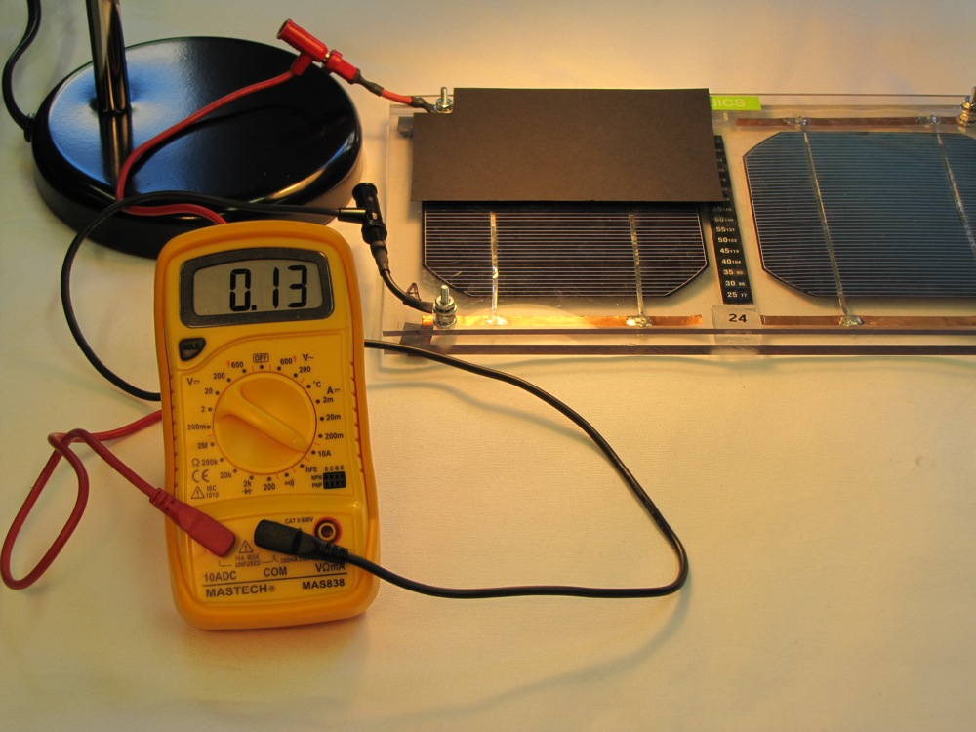

**Measuring current when ½ of solar cell is covered**

# MATERIALS

* PV Cell Module
* Electrical Leads
* DC ammeter
* DC voltmeter
* 2 Lamps or Sun
* Blocking Cardboard
* Multimeter instruction sheet

# OVERVIEW: The short circuit current is measured when the solar cells are connected in parallel and series. An experiment is conducted on the effects of shading on the solar cells by shading first 50% of one cell, then 100% of the cell. Then the second cell is shaded by 50% and then both cells are shaded. The student is then asked to use the data collected to compare the effects of shading on the solar module when the cells are connected in series or in parallel.

The procedures in the first experiment are used to setup this experiment that evaluates the effect of shading on the solar cells connected in series and parallel. First, we want to know the inherent parameters of each cell. Illuminate the cells with lamps or sunlight.

# Part I.: Determining the Short Circuit Current and Voltage and Open Circuit Voltage

 

Fig. 2.1: Measuring the short circuit current Fig. 2.2: Measuring open circuit voltage

1. Connect the amp meter and **measure** and **record** the short circuit current for each cell (see Fig. 2.1). Do this for each cell separately.
2. Connect the volt meter and measure and record the open circuit voltage for each cell (see Fig. 2.2). Enter the data into Table 2.1.

|  |  |  |
| --- | --- | --- |
| **Table 2.1: Parameters of Cells** | | |
| **Parameter** | **Cell A** | **Cell B** |
| Short Circuit Current (A) |  |  |
| Open Circuit Voltage (V) |  |  |

**Part II: Effect of Shading on Short Circuit Current for Solar Cells in Parallel**

Connect the two cells in parallel and use the amp meter to measure the short circuit current as shown in Fig. 2.3

Fig. 2.3: Connections for measuring short circuit current with solar cells connected in parallel.

A

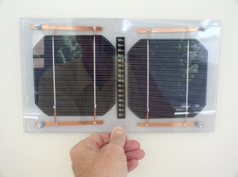

Lamp

Lamp

1. Using the above data in Table 2.1, fill in Data Table 2.2 **with predicted currents,** what you think the current will be when the cells are connected in parallel, and when one of the cells is covered by the amount stated.
2. Next, connect the cells in parallel and set-up the amp meter to measure the short circuit current output from the PV module (see Fig. 2.3). Cover the cells by the various amounts listed and record the current in Table 2.2.

### Table 2.2: Shaded currents, two cells in Parallel

|  |  |  |
| --- | --- | --- |
| **Cover Amount. (Shade)** | **Predicted Current (Amps)** | **Measured Current (Amps)** |
| No shade |  |  |
| Cell A 50% covered |  |  |
| Cell A totally covered |  |  |
| Cell A totally covered plus 50% of cell B |  |  |
| Both cells covered |  |  |
| Cell B 50% covered |  |  |
| Cell B totally covered |  |  |
| Cell B totally covered plus 50%of cell A |  |  |
| Both cells covered |  |  |

# Part III: Effect of Shading on Short Circuit Current for Solar Cells in Series

Connect the two cells in series and use the amp meter to measure the short circuit current as shown in Fig. 2.4

Fig. 2.4: Connections for measuring short circuit current for solar cells connected in series

A

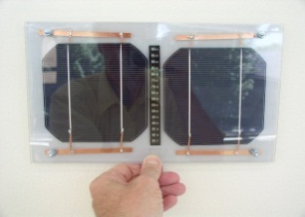

Lamp

1. Using the above data in Table 2.1, fill in Data Table 2.3 **with predicted currents,** what you think the current will be when the cells are connected in parallel, and when one of the cells is covered by the amount stated.
2. Next, connect the cells in series and set-up the current meter to measure the short circuit current output from the PV module (see Fig. 2.4). Cover the cells by the various amounts listed and **record** the **measured currents** in Table 3.3.

**Table 2.3:** **Shaded currents, two cells in Series**

|  |  |  |
| --- | --- | --- |
| **Cover Amount (Shade)** | **Predicted Current (A)** | **Measured Current (A)** |
| No shade |  |  |
| cell A 50% covered |  |  |
| cell A totally covered |  |  |
| cell A totally covered plus 50% of cell B |  |  |
| Both cells covered |  |  |
| cell B 50% covered |  |  |
| cell B totally covered |  |  |
| cell B totally covered plus 50%of cell A |  |  |
| Both cells covered |  |  |

Questions:

What relationship exists between the amount of shade and current output in the parallel case?

Does the current decrease by 1/2 when one cell is covered?

**Discussion:**

What relationship exists between the amount of shade and current output in the series case? (You can plot a graph of Current vs. Amount of Shade to try and see what kind of relationship exists.)

Does shading affect the solar module different if the cells are connected in series than if they are connected parallel? If yes, why is this so?

EXTRA INVESTICATION SUGGESTION. You can repeat the experiment and measure the voltage instead of the current.