# **PV Activity 3 – PV Loads©**

* The purpose of this activity is to investigate the current and voltage output of photovoltaic cells when connected to various loads.
* This activity includes an optional extra investigation related to power curves, an engineering characteristic of the PV cell.

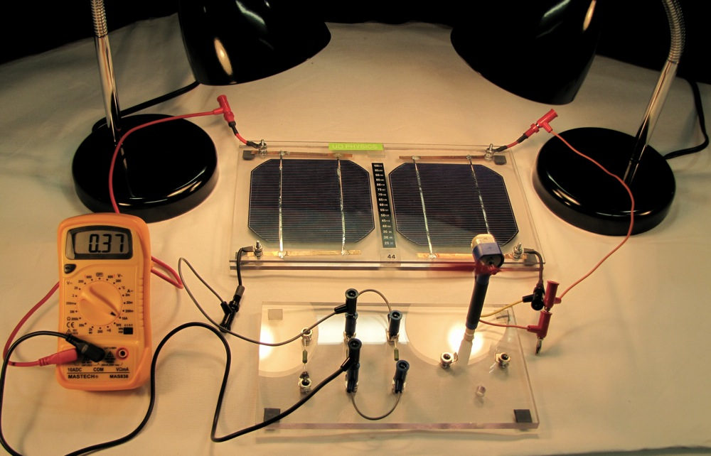

Testing the PV module current with loads

# **MATERIALS**

The following materials are required for Lab Activity 3

* PV Cell Module
* 2 Lamps or access to direct sunlight
* Electrical Leads
* DC ammeter
* DC voltmeter
* Fans
* Miniature Light Bulb
* Component Board with resistors.

**Procedure**: Illuminate the cell(s) with incandescent lamps to keep the amount of light incident on the cell constant. Place the lamp close to the cell and be sure the distance between the lamp and the cell is the same for all measurements. Also to keep the lamps from getting too hot, we suggest turning off the lamps between actual measurements. Knowledge of how to connect cells in series and parallel learned in PV Activity 1 is required.

**Part I: Measuring Voltage, Current, and Power under load**

### Part A: Visual Work

Connect one PV cell to a fan as an electrical load. Connect the black terminal fan plug to the black connector on the PV panel and the other fan plug to the red connector on the PV module.

You can see that the cell can indeed provide energy to make something run. What we want to do in this experiment is investigate the power output of the cell and how output current and voltage change when solar panels are connected in series or parallel.

Questions to be address:

* How are these cells connected?
* What is the maximum Power one can attain with a solar cell?
* How does load affects the Power produced by solar cells

**Part B: Loading the PV Cell**

The circuit component board has resistors mounted for easy connection. (A resistor is a circuit element that has many uses in electronics.) This experiment examines the effects of demanding energy from the cells. This is commonly called **connecting a load** to the circuit.

Connect both meters to the circuit as shown in Fig. 3.2. To connect the current meter, connect the 10A ammeter input to the + terminal of one PV cell with a jumper wire and the COM input to one side of a 0.5Ω resistor on the board with another wire. Connect the other side of the resistor to the – terminal of the cell with a jumper wire. Connect the Voltmeter directly across the PV cell terminals being used. **Simultaneously measure voltage and current and record your measurements into Table 3.1.**



Fig. 3.2: Connecting to a resistor load

**Part C1: Voltage, Current, and Power for One Cell**

1. **Measure** and **record** the Voltage and Current being delivered with one 0.5Ω resistor in the circuit.
2. The Power (P) (energy/time measured in Watts) being delivered by the cells(s) is the product of Voltage times the Current. For the third column in Table 3.1 calculate and enter the power being delivered to the resistor by the cell by taking the product**: P=IV**

**Table 3.1**: **Measurements of Voltage and Current and Calculation of Power**

|  |  |  |  |
| --- | --- | --- | --- |
|  | **V = Voltage (V)** | **I = Current (A)** | **P = Power = IV (W)** |
| One resistor (Total Resistance = 0.5Ω)One Cell |  |  |  |
| Two resistors (Total Resistance = 0.25Ω) One Cell |  |  |  |
| Two resistors (R = 0.25Ω)Two PV Cells in Parallel) |  |  |  |
| One resistor (R=0.5Ω)Two PV Cells in Series |  |  |  |

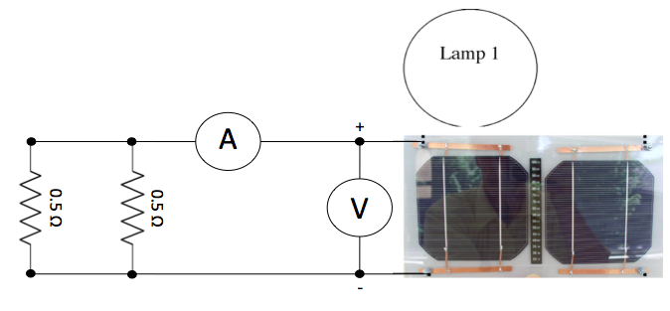

Fig. 3.3: Connecting two resistors in parallel

1. Now use jumper wires and connect the second 0.5Ω in parallel with the first resistor (see Fig 3.3). This will decrease the resistance by a factor of 2 because the current now has two paths of equal resistance to travel. Measure the Voltage, and Current, and determine the Power. How do they compare to the measurement with just one resistor?

**Part C2: Voltage, Current, and Power for Two Cells in Parallel**

1. Now connect the second PV cell in parallel with the first and illuminate each cell with a lamp. To connect cells in parallel attach the black connector of one cell to the black connector of the second cell and the red connector of one cell to the red connector of the second cell. **Measure** and **record** the Voltage, Current, and calculate the Power. Has the current or voltage changed? How does the current and voltage compare with the two previous currents measurements?

PV cells are much like batteries only they are powered by the sun. If the PV cells “kept up with the load” one would expect the current to double when the resistance decreased by a factor of two. To first approximation, one might assume that the voltage would stay constant as resistive loads change. How well did this work with one PV cell? Did it work better with two cells in parallel? (See **Solar Cells, IV Curve, and Power** at the end of this Activity.)

**Application**: Given a consistent amount of incident light, there is a maximum amount of current a solar cell can produce. If a load demands more current, then one has to connect more solar cells in parallel to meet the additional current demand.

**Part D: Power, Two Cells in Series**

1. Connect the two cells in series (refer to PV Activity 1) to one 0.5Ω resistor. **Measure** and **record** the Current, Voltage and calculate the Power in Table 3.1. How does the Power compare with one 0.5Ω connected to one cell measured in Part C Step 1? How much did the voltage and current change?

**Application**: Voltage (energy per charge) is related to the energy delivered by each charge. Two PV cells connected in series increases the energy for each charge. However, the current remains constant. The power delivered is higher since the energy per charge is greater and but the number of changes remains the same. This is one reason why solar cells are connected in series in Solar Panels, to be able to provide enough voltage to meet the rated requirements.

### Discussion: Write down your comments and what you learned or questions you have after completing Part I.

### Part II: Rated Voltage and Power

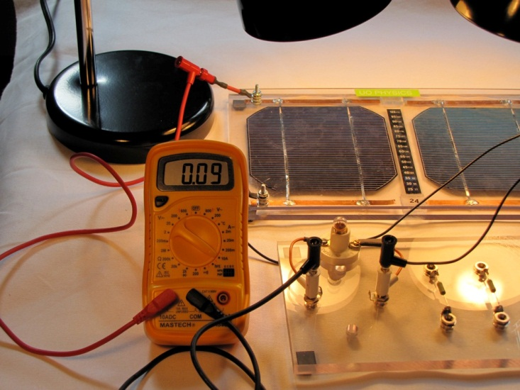Devices are designed to operate at a specific Voltage and Power. The electrical charges must have the right energy in order to make the device operate properly. This Part will look at this aspect of an electrical circuit.

Replace the resistor loads with the miniature light bulb and measure the current by connecting the ammeter in series with the light bulb. (The10A ammeter input to the + terminal of one PV cell and the meter COM input to one lead of the light socket. Connect the other socket lead to the – terminal of the cell. Connect the Voltmeter directly across the PV cell terminals.)

Fig. 3.4: Testing the load caused by a light bulb.

# **Part A: Testing the Current, Voltage, and Power with a Light Bulb as a Load – One Cell**

1. Illuminate the PV cell and **measure** and **record** the Current, Voltage, and calculate the Power being delivered to the bulb. Also note the brightness of the miniature bulb. (Dim, Bright, Brightest)

# **Part B: Testing the Current, Voltage, and Power with a Light Bulb as a Load – Two Cells**

1. Connect the second PV cell in parallel with the first cell and again measure the Current, Voltage, and Power delivered to the miniature bulb. Is the bulb brighter than it was in step 1?
2. Connect the second PV cell in series with the first cell. Again measure the Current, Voltage, and Power being delivered to the miniature bulb. Is the bulb brighter than in steps 1 and 2? Which produces the brightest light output, the cells connected in series or parallel?

**Table 3.2: Current, Voltage, and Power with a Light Bulb**

|  |  |  |  |  |
| --- | --- | --- | --- | --- |
|  | **Voltage (V)** | **Current (A)** | **Power (W)** | **Bulb Brightness** |
| Light Bulb, One Cell |  |  |  |  |
| Light Bulb, Two Cells in Parallel |  |  |  |  |
| Light Bulb, Two Cells in Series |  |  |  |  |

**Application:** Devices are designed to consume power at a particular voltage. Cells must be connected in series and parallel combinations to provide power (P=IV) at the required voltage. The miniature bulb requires at least 1V to light properly, so there is a need to connect cells in series to obtain the voltage needed for the light bulb to light. If we wanted to light a high number of bulbs, at some point we would need to increase the current capability. Adding an additional two cells in series to get the proper voltage, and then connect this set of connected series cells in parallel to increase the available current being delivered to the bulbs.

You can see that it takes a combination of cells to construct a Solar Panel. Some cells must be connected in series to meet the desired voltage and these series connected cells must be connected in parallel to produce the needed current. The same holds true for designing a system with solar panels. Individual solar panels must be connected in series and parallel combinations to obtain a system operating at a desired voltage and power output.

**Discussion:** Write down your comments and what you learned or questions you have after completing Part II.

**Extra Exercise:**

Assume each PV Cell is capable of delivering 0.5V and 1.5 Amps. How would you connect PV cells to obtain 3V with a power output of 9 Watts?

**Part III A Power Curve (Extra for Experts!)**

Any electrically powered system has parameters where it operates. One parameter for PV cells is called The Power Curve, used by engineers to determine how to design a system for maximum efficiency. This exercise shows how the power curve for a PV cell can be determined.

As you investigated in Part I C, the amount of power a PV cell puts out is dependent on the load it is delivering power too. By taking a few more data point you can plot the power curve for these cells and determine at what load resistance is the maximum power delivered.. (Note: For this part we must take into account the actual resistance of the current meter. Ideally it would be zero, but its actual value is 0.044Ω)

1. Transfer your data from Table1 into the first two rows of Table 3 and record the measurements below into Table 3.
2. Connect jumper wires to parallel connect the two 0.50Ω resistors to the 0.25Ω. (Total resistance is now 0.125Ω) This connection will again decrease the resistance by another factor of 2 from before, or by a factor of 4 from the first measurement. **USE ONLY ONE CELL** and record the Voltage, Current, and Power.
3. Disconnect the resistors and now connect the current meter directly across the OPV cell terminals. To measure the short circuit current. Keep the voltmeter connected across the terminals. (Ideally, the Resistance here would be zero, and the Voltage would also be zero. However, the current meter has a resistance of 0.044Ω therefore we do not quite have a complete short circuit.)
4. Disconnect current meter. You can now measure the open circuit Voltage, Current and Power are now zero. The Voltmeter will still have a reading since it is connected directly to the PV cell

Table 3: Power Curve Data: ONE CELL

|  |  |  |  |  |
| --- | --- | --- | --- | --- |
|  | **Total R** | **Voltage (V)** | **Current (A)** | **Power = IV (W)** |
| One resistor (0.5Ω) | 0.544Ω |  |  |  |
| Two resistors in parallel (0.5Ω) * | 0.294Ω |  |  |  |
| Three resistors in parallel(R = 0.125Ω) | 0.169Ω |  |  |  |
| Short Circuit(R= 0.044Ω) | 0.044Ω) |  |  |  |
| Open Circuit | Infinity |  | 0 | 0 |

* Data from Table 1

To investigate Power Curves of a PV cell, you will need to plot a number of graphs.

**Current vs. Voltage:** This graph would show you at that at some point, the linear relationship between current and voltage starts to break down at low resistance because the cell cannot provide enough current. This is what we observed in Part C.

**Power vs. Voltage:** Roughly the same as the previous graph, just looked at in regards to Power. You can see there is a point where the Power peaks.

**Power vs. Resistance:** You can actually determine the resistive load where the maximum Power would be delivered. This would be the Peak Power rating. The Peak Power is when the resistance of the course is equal to the resistance of the load. Pretty advanced stuff, but this is what is looked at when systems are engineered and given rated specifications.

**Discussion and results if you have performed this exercise.**

# **Solar Cells, IV Curve, and Power**

At a given level of irradiance, the amount of power generated by the solar cell varies dependent upon the load. By varying the load from zero at short circuit current to infinity at the open circuit limit all possible combinations of current and voltage are traced out. This is called the IV curve.



Fig. 3.6: Plot of current verses voltage for a solar cell module. Power is the product of current times voltage. The power scale is on the right. The voltage and current where their product produce the most power is called the max power point and Vmp and Imp are the max power voltage and current respectively. Short circuit current is labeled ISC and open circuit voltage is labeled VOC.

The load on the circuit determines the voltage and current. Depending on the position on the IV curve, an increase in load can increase or decrease the power output by the solar cells. Doubling the number of cells will generally increase the power, but the power increase will depend on the current and voltage dictated by the load. Modern inverters contain max power point trackers that adjust the perceived load to operate the facility at maximum possible output. A photovoltaic system connected to the utility grid contains an inverter that changes direct current and voltage from the solar array to alternating current that is available on the utility grid.

When two cells are connected in parallel, the current doubles and the voltage stays the same. When the two cells are connected in series, the voltage doubles and the current stays the same. Either way, the power doubles.

The response of the load to doubling the current or voltage is dependent on the type and characteristics of the load.